Rittal Automation Systems Bending Terminal BT 20E
Bending busbars professionally: rapidly, precisely and automatically
Herborn, 1 April 2025
The new Bending Terminal BT 20E from Rittal Automation Systems can be used for many types of quick and precise bending of copper and aluminium busbars, such as flat, edge or multi-stack bending. This enables busbars up to 20 mm thick and 160 mm wide to be processed automatically with a high bending precision. The bending machine’s electric drive provides significant energy savings and a quiet operation. Another benefit: The combination with Eplan software enables consistent, digital interaction for greater efficiency across the entire value chain in plant engineering, from planning the system to operating the equipment.

Switchgear manufacturers play a key role in the rapid conversion and expansion of energy systems. They find optimisation potential in industrialised work processes, which must be accelerated, made more efficient and standardised. This can only be achieved through digitisation and automation. Rittal Automation Systems now supports the machining of busbars with a new bending machine: the Bending Terminal BT 20E.
From engineering to processing reliability
Bending busbars – either manually or mechanically – is far from trivial. Errors can occur faster than expected, for example, due to inaccurate bending angles or cracks in the material, which results in rejects. Process reliability is only possible with automated production, which has software and digital interfaces for data imported from engineering: This significantly reduces defects, while product quality is improved and speed increased. Furthermore, the machine’s visualisation tools help the machine operator insert the busbars correctly. These requirements were all taken into account when developing the new Bending Terminal.

Data import without problems
The bending machine offers many options for programming the workpieces and nesting production orders. Thanks to networking with a database, time-consuming data transfers between other machines are no longer needed. The machine can be programmed directly at the machine or from the office workstation using the standard “PowerBend” software. This ensures easy, intuitive programming, even of complex workpieces. The machine software also supports data imported from Eplan’s Pro Panel and Rittal’s RiPower, manufacturer-independent DXF formats, and Optimation, Metamation and WiCAM.

Exact and energy-efficient
Using the Bending Terminal, various copper and aluminium workpieces up to 20-mm thick, 160-mm wide and at least 40-mm long can be bent with a precision of 0.2°, regardless of whether they are flat, edge or multi-stack bent. Thanks to an integrated electronic angular measuring system featuring springback compensation, the desired bending angle can be achieved with high precision right from the start. Its electric drive with a maximum force of up to 240 kN makes Bending Terminal BT 20E particularly quite, low-maintenance and efficient. A special connector system on the machine ensures short change times for the bending tools, so ensuring user-friendly and easy tool changes. The automated, CNC-controlled side-stop ensures the precise positioning of the tools.
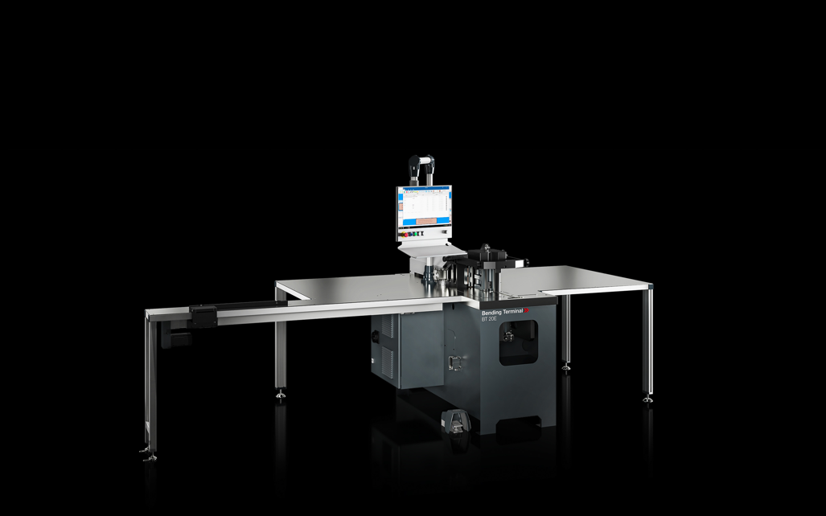
Whether flat, edge or multi-stack bending – the new Bending Terminal BT 20E from Rittal Automation Systems bends copper and aluminium busbars quickly and precisely.

May be reproduced free of charge. Please name Rittal GmbH & Co. KG as the source.

Rittal

Rittal is a leading global supplier of enclosure systems, automation and infrastructure with its industrial, IT, energy and power, cooling and service units. Rittal products and solutions are used in over 90% of global industries – standardised, customised, and always of the very best quality.
Our approach and methodology: Rittal, Rittal Software Systems (Eplan, Cideon) and Rittal Automation Systems (RAS, Ehrt, Alfra) combine their hardware and software expertise to streamline, optimise and digitalise processes across the entire value chain for our customers including their IT infrastructure – from control and switchgear construction, machine building to factory operators or the energy sector.
Our delivery promise: Rittal standard products are delivered in Germany within 24 hours, and within 48 hours throughout Europe.
Customer focus
Improving efficiency and increasing productivity through automation and digitalisation is one of the biggest challenges for our customers. This requires in-depth knowledge and expertise, the combination of hardware and software, and cross-sector networking. We are convinced that creating and connecting data rooms is crucial to the success of industrial transformation. And that is exactly our speciality and field of competence.
Eplan and Rittal are driving the development of the digital automation twin, making data accessible and useable in operations as well. Cideon is improving data consistency in the digital product twin context with its CAD/CAM, PDM/PLM and product configuration expertise.
Sustainability
Environmental and climate protection, social commitment and ethical corporate management are a given for Rittal. We take our responsibility for a sustainable future seriously. Our approach to resource management and conservation involves continuous improvement of our own production processes and ensuring that our products have the lowest possible Product Carbon Footprint. Our solutions support our customers in achieving their own climate targets.
Family business and global player
Founded in 1961, Rittal is the largest company in the owner-operated Friedhelm Loh Group. The group operates worldwide, with 12 production sites and 95 international subsidiaries. It has 12,100 employees and posted revenues of 3 billion euros in fiscal 2023. In 2023, the Friedhelm Loh Group was presented with the “Best Place to Learn” and “Employer of the Future” awards. In 2024, Rittal was awarded the Top 100 Seal as one of Germany’s most innovative medium-sized companies for the third time in a row.

For more information, visit www.rittal.com and www.friedhelm-loh-group.com.

Corporate Communications
Dr. Carola Hilbrand Rittal GmbH & Co. KG
Corporate & Brand Communications Auf dem Stützelberg
Phone: +49 (0)2772/505-2527 35745 Herborn, Germany
hilbrand.c@rittal.de www.rittal.com

